Case Discussion Facilitation Framework
How to Add Structure to Case Discussions
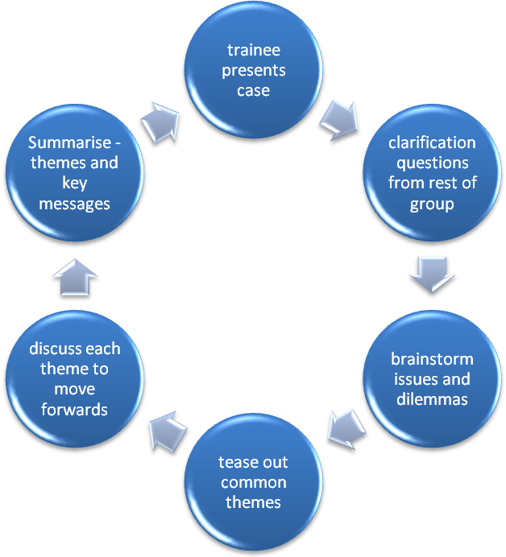
- Present case uninterrupted – ensure the trainee is uninterrupted. They must present the case from their own viewpoint, so we can put ourselves in his/her shoes and see, hear and feel what they saw, heard and felt.
- Clarification from rest of the group – make sure this is not too lengthy otherwise it will hijack the whole session with little time left for discussion and moving forwards; say 10 minutes of clarification. Questions should be focussed on “clarifying matters of fact”. Stop others who ask questions about the trainee’s reasoning behind the actions taken (that can form part of the group discussion). Also, stop others from problem solving or saying what they would have done as this will form part of the discussion: “can I just stop you there because that’s really useful information that we’ll come to later. Is that okay?”
- Brainstorm issues and dilemmas – from the whole group; may be starting with the presenter of the case. The issues you want are not just the presenting person’s ones but that of the other individuals in the group (as if they were in the scenario themselves). Don’t worry if you end up with a big list.
- Tease out common themes – this will help bring your long list down to around 3-6 themes. You’ll be able to link brainstorming items together. Get the group to help you.
- Discuss options and ways forwards: discuss each theme in turn. Some may naturally flow into the next theme (allow that to happen – in that way, you “kill two birds with one stone” and is very time effective. Remember, don’t allow any more questions relating to clarifying matters of fact, otherwise you’ll end up going around in circles and the whole session will appear unstructured and thus difficult for the learners to recall the important key messages/learning points.
- Summarise – Look at what has been covered and then cover the key points; get the members of the group to summarise the key messages for them.

Some of you may recognise that this structure is similar to that used in Balint group discussions; during discussions, you may even wish to consider getting the presenter of the case to move out of the small group circle and sit quietly for a while at step 5. This helps them to listen without interrupting the rest of the group discussion (and thus allows discussions to the full without the trainee constantly defending or justifying themselves, maximises learning for all and enable the presenter to reflect and take on key messages for them).

